**Data Structures** are different ways of organizing data on your computer, that can be used effectively.

**Algorithms –** set of steps to accomplish a task. In CS, it’s a set of rules for a computer program to accomplish a task.

What makes a good algorithm?

* Correctness
* Efficiency

**Types of Data Structures**

1. Primitive data structures – built in the programming language itself and are available to the programmer e.g. integer, float, character, string, and Boolean
2. Non-primitive data structures – user defined data structures, combine two or more data structures divided into:

Linear data structure – data items are arranged in memory in a linear sequential manner and can be static or dynamic. Static linear DS – structured associated memory locations are fixed in the runtime but in dynamic linear DS memory locations change.

Non-linear DS – data item is connected to several other data items.

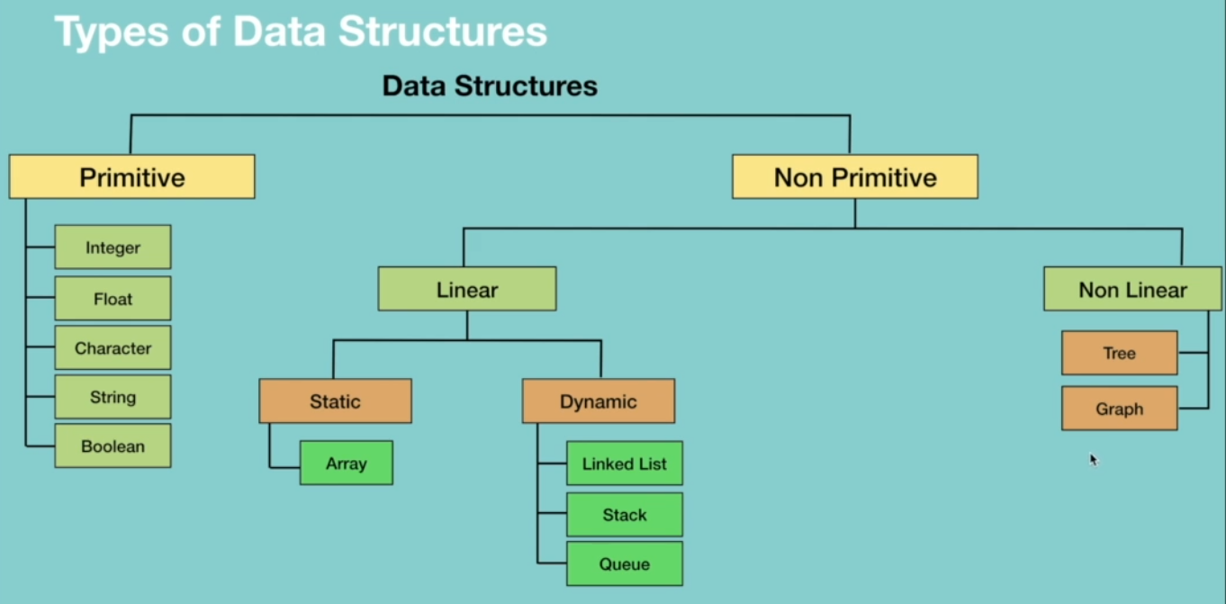



**Types of Algorithms**

They are classified either based on the type of problem they are trying to solve or based on the problem-solving technique.

They include:

* Simple recursive algorithms
* Divide and conquer algorithms
* Dynamic programming algorithms
* Greedy algorithms
* Brute force algorithms
* Randomized algorithms

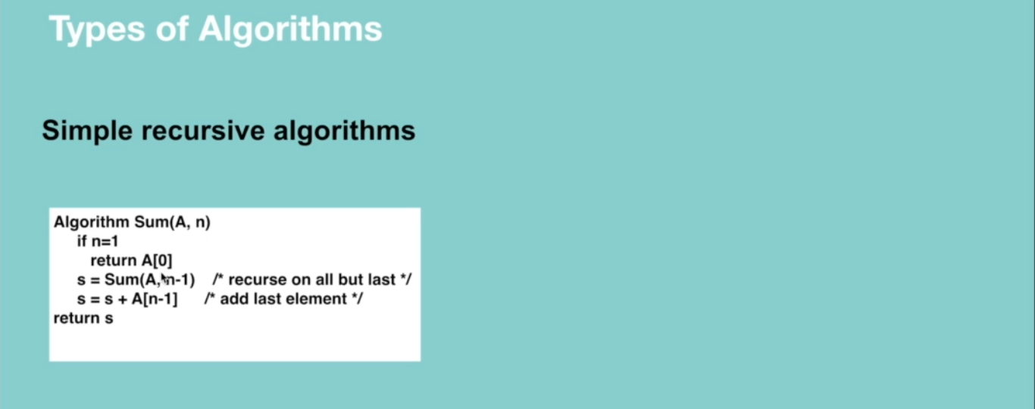

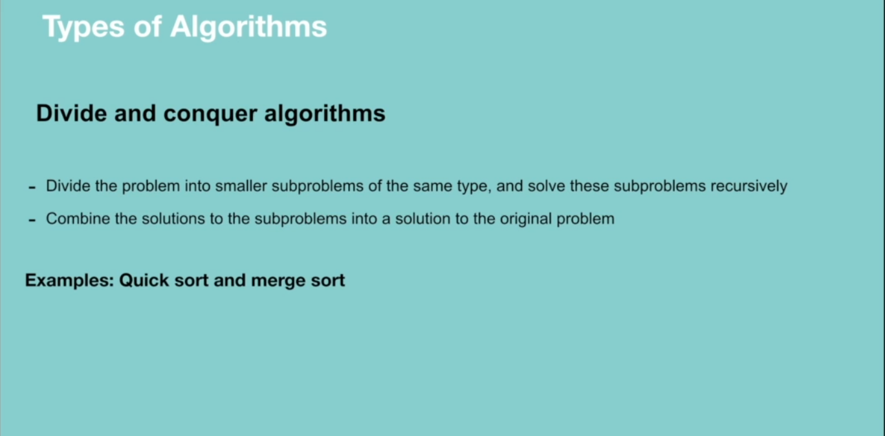

Dynamic programming works on memoization which means the algorithm remembers the past results and use them to find new results. It’s generally used for optimization problems i.e. to find the best solution among multiple solutions.

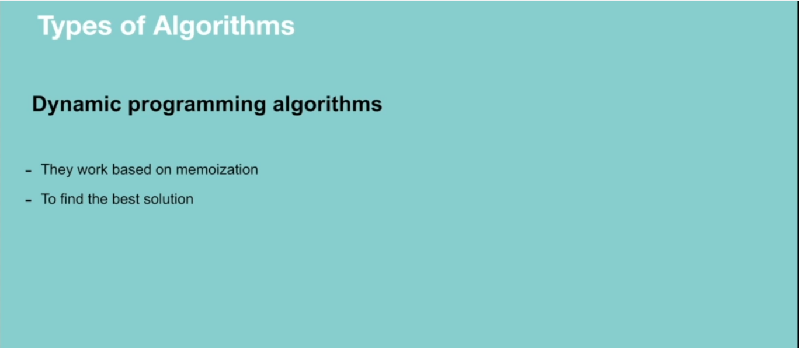

Greedy algorithm works in phases. It’s also used for finding the best solution i.e. optimization problems.

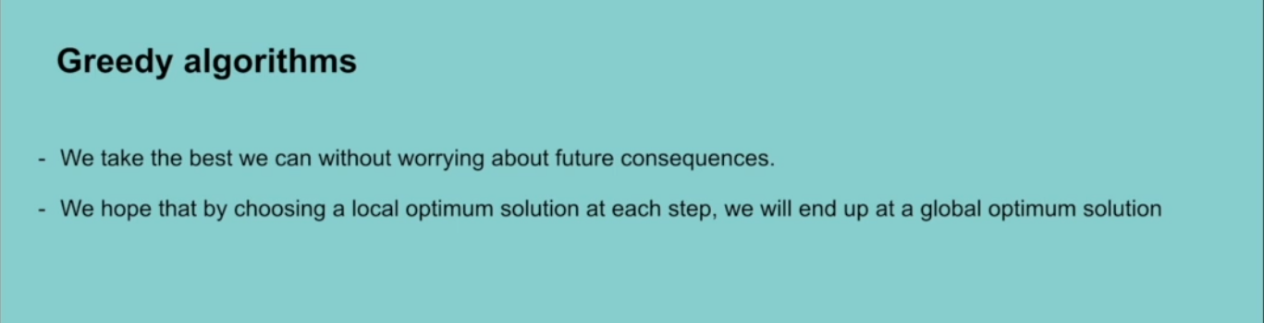

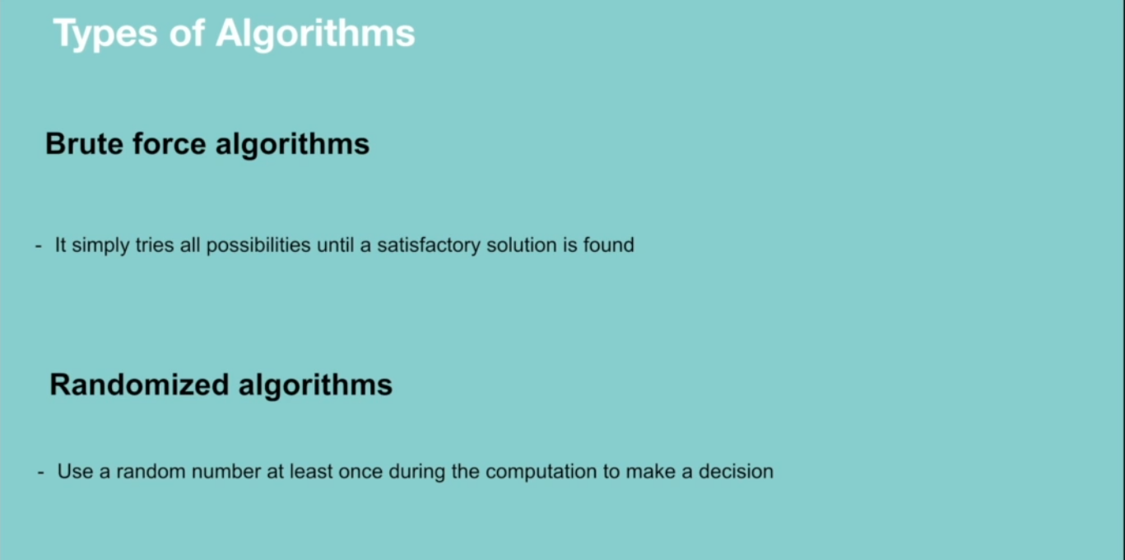

**RECURSION**

A way of solving a problem by having a function calling itself.

**Properties of recursion**

* Performing the same operation multiple times with different inputs.
* In every step we try smaller inputs to make the problem smaller.
* A base condition is needed to stop the recursion.

**Why Recursion?**

* Recursive thinking is really important in programming and it helps you break down big problems into smaller ones and easier to use. Note: There are situations when iterations perform better than recursion.

When to choose recursion – when you can divide the problem into similar subproblems. The subproblem must be similar otherwise recursion is not a choice.

**How do you know that the subproblem is similar in nature?**

* Design an algorithm to compute nth…
* Write code to list the n…
* Implement a method to compute all.

**Why Recursion**

* The prominent usage of recursion in data structures like trees and graphs.
* Many big companies ask questions in relation to recursion in the interviews.
* It is used in many algorithms (divide and conquer, greedy and dynamic programming)

**How Recursion works**

When designing a recursive call, we have to consider two conditions:

* A condition where a method calls itself with similar values.
* A condition to exit from the infinite loop.

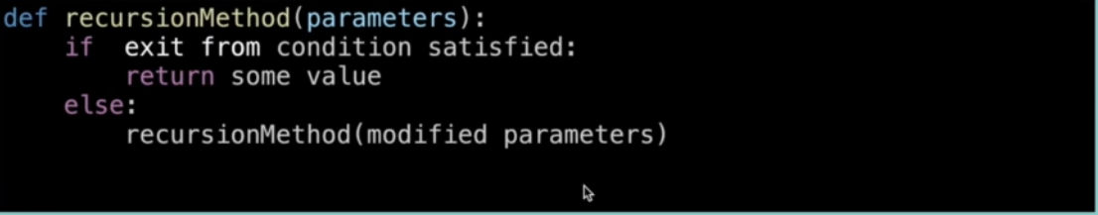

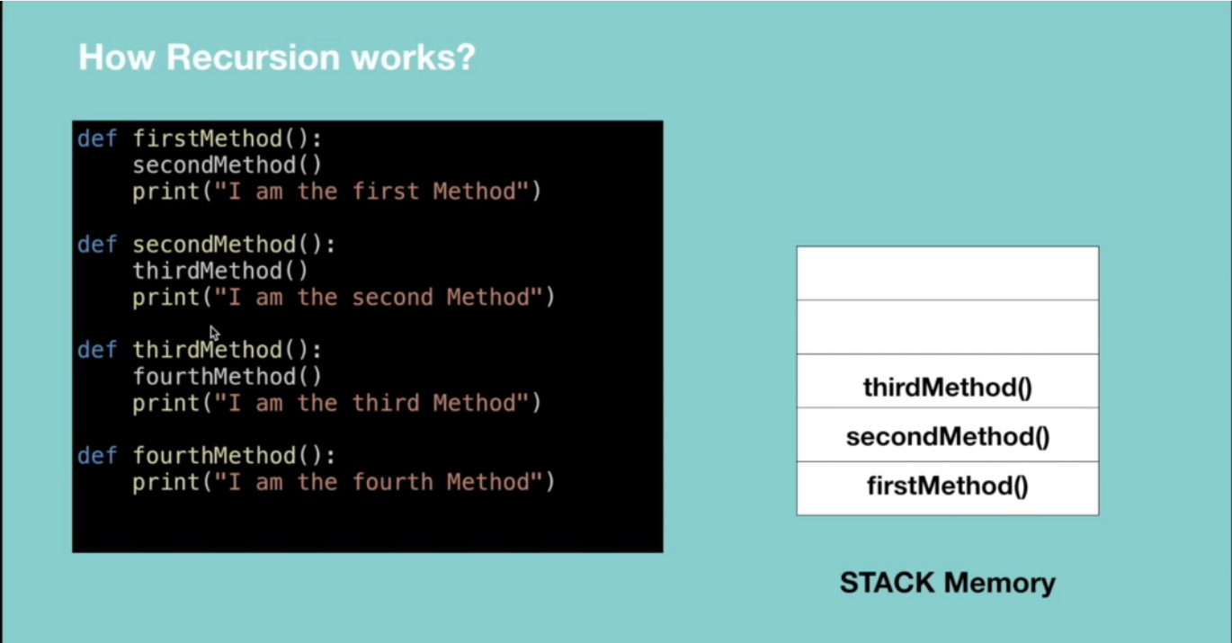

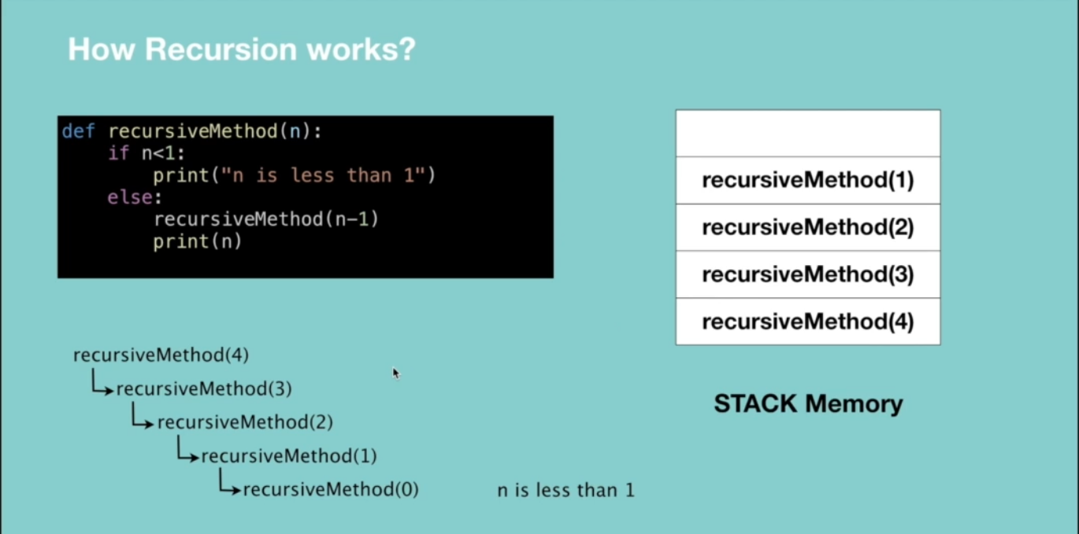

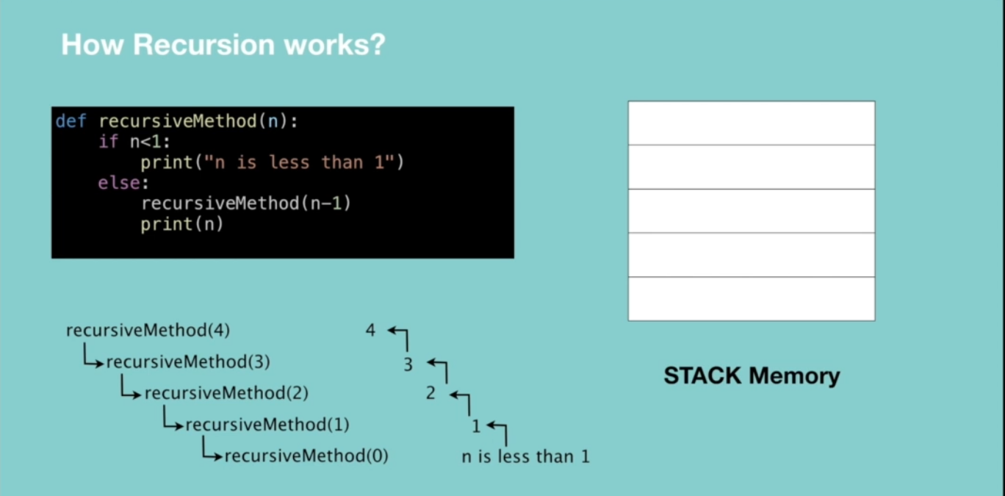

**Recursive vs Iterative solutions.**

All recursive methods can be implemented iteratively.

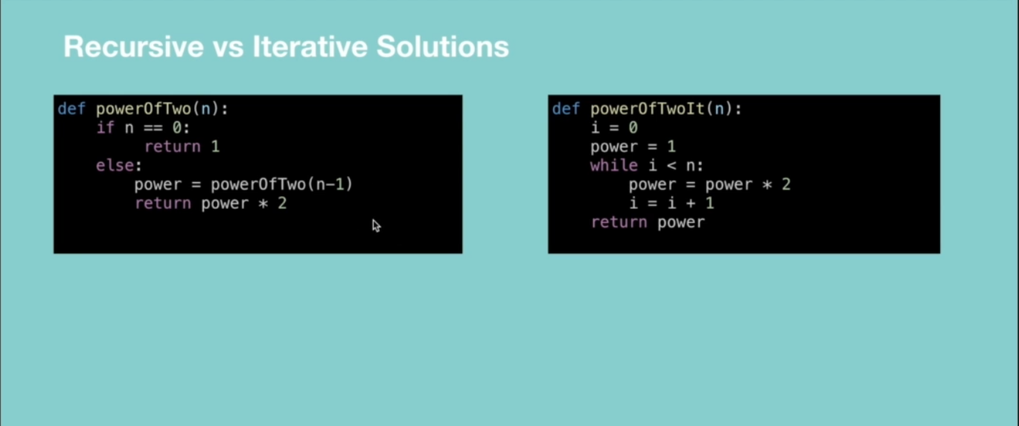

* In recursion, a conditional statement determines the termination of the function while in iterative solutions a controlled variable value decides the termination.
* In recursion, infinite recursion can lead to a system crash while infinite iterations consume CPU cycles.
* Recursion repeatedly invokes the mechanism consequently overhead of method calls, this is expensive in both processor time and memory space while iteration does not.
* Recursive algorithm can be very space inefficient. i.e. if your algorithm resources to the depth of N, it uses at least O(N) memory hence it’s better to implement recursive algorithm iteratively.

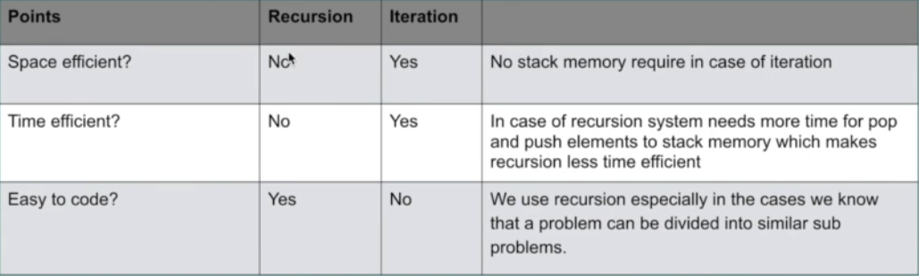

**When to Use/Avoid Recursion?**

**When to use it?**

* When we use memoization in recursion – this reduces the time complexity.
* When we can easily breakdown a problem into similar subproblem
* When we are fine with extra overhead (both time and space) that comes with it. Note when you are developing a mobile app which should run on low memory devices, then here recursion is not advisable. If you’re designing a critical system like an airbag in the car, don’t use recursion.
* When we need a quick working solution instead of efficient one e.g. factorial and Fibonacci numbers.
* When traverse a tree

**When avoid it?**

* If time and space complexity matter for us.
* Recursion uses more memory. If we use embedded memory. For example, an application that takes more memory in the phone is not efficient.
* Recursion can be slow.

**How to write recursion in 3 steps**

Factorial => the product of all positive integers less than or equal to n.

**Step 1: Recursive case – the flow**

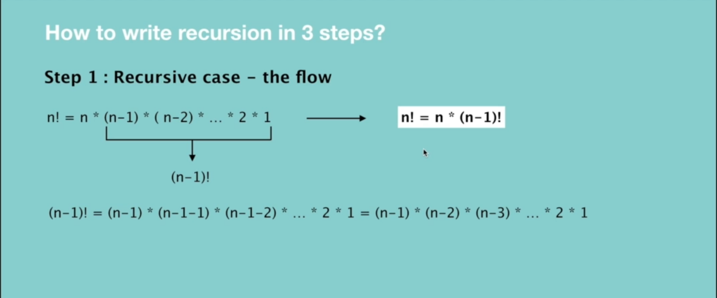

**Step 2: Base case – the stopping criteria**

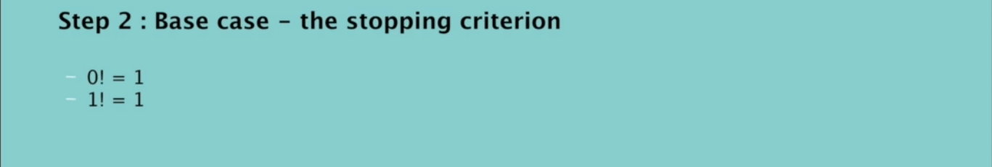

**Step 3: Unintentional case - the constraint**

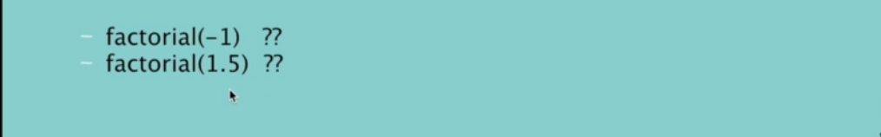

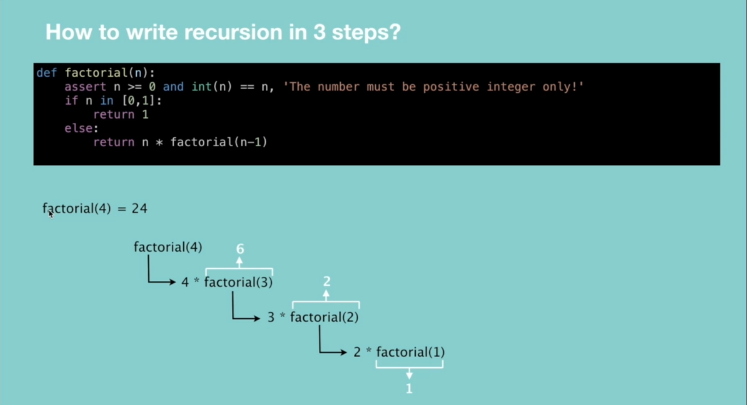

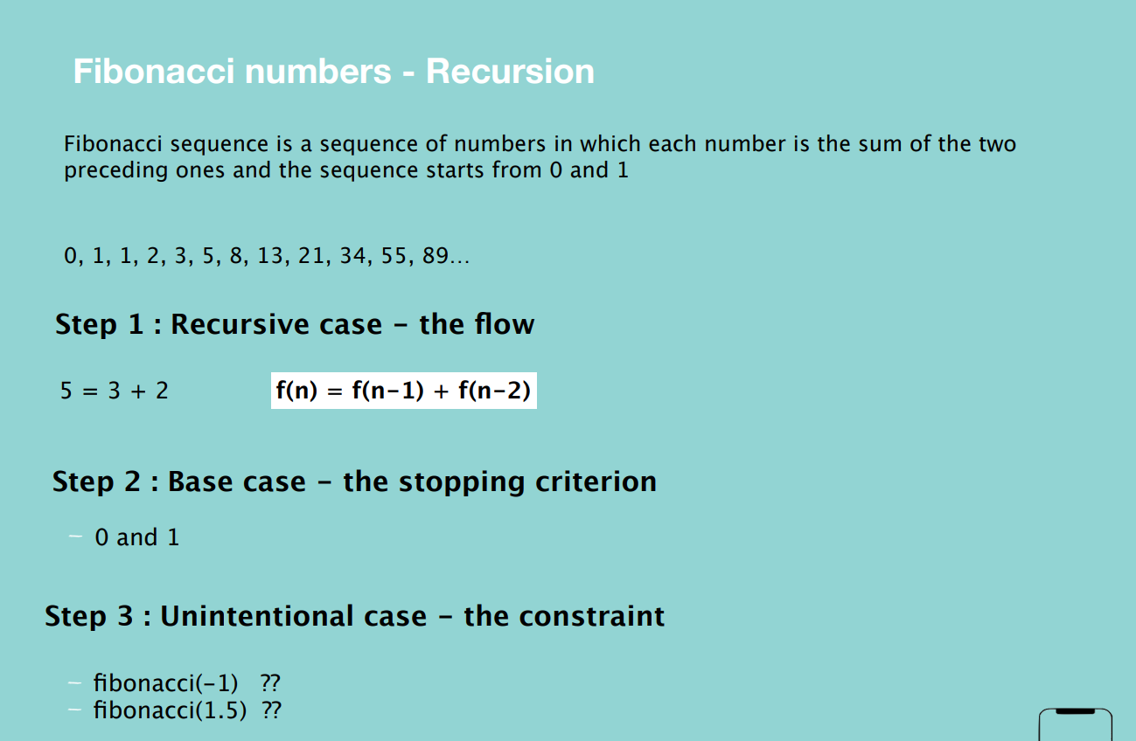

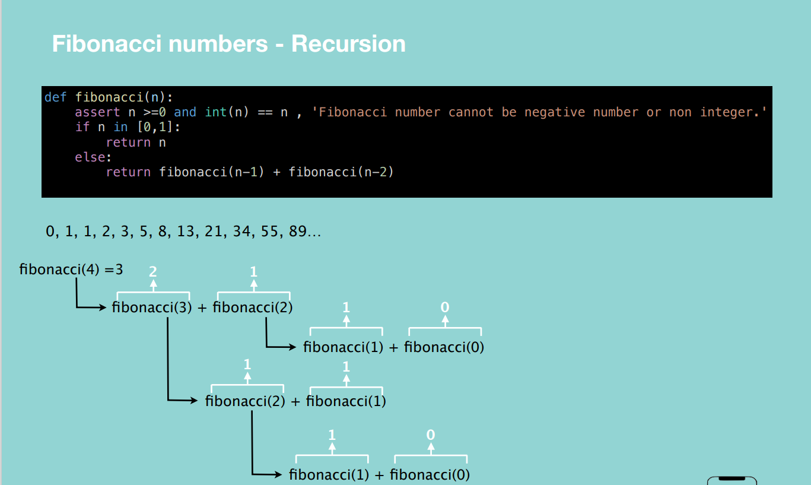

**Interview Questions**

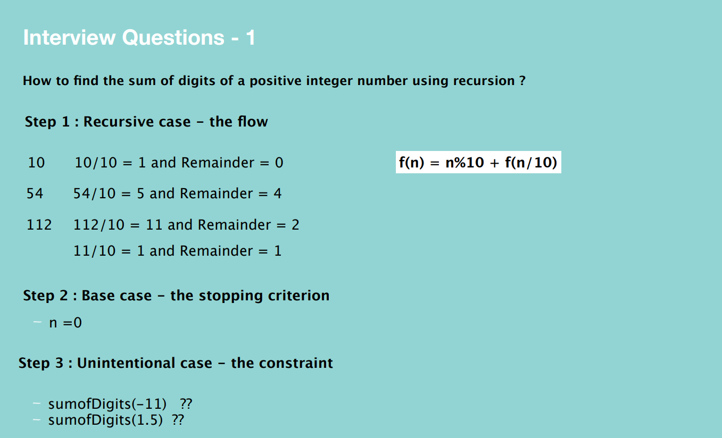

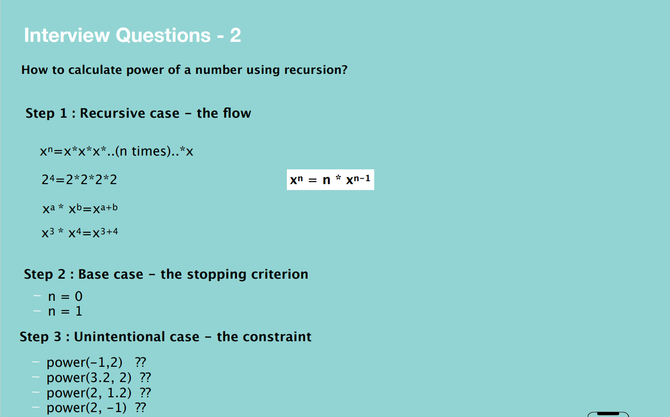

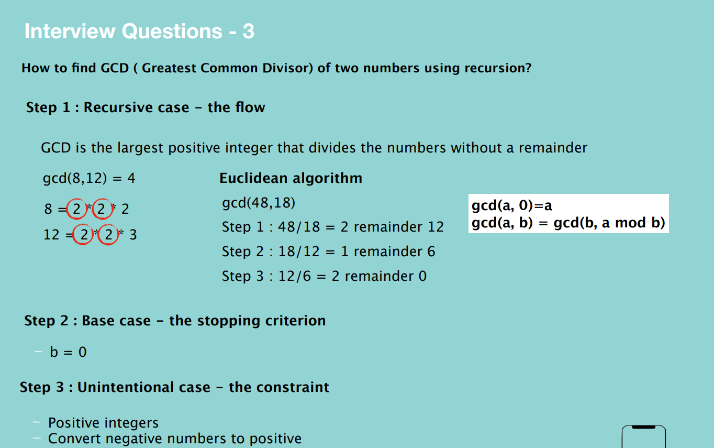

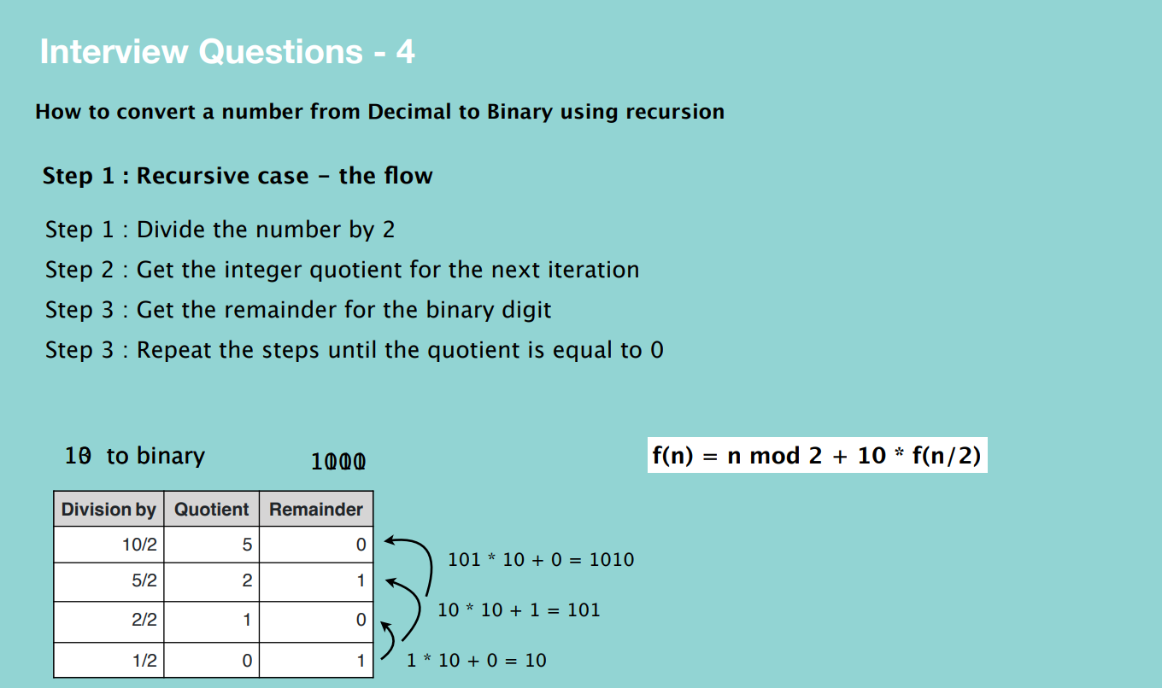

**BIG O**

Big O is the language and metric we use to describe the efficiency of algorithms.

**Time complexity –** shows how the runtime of a function increases as the size of input increases.

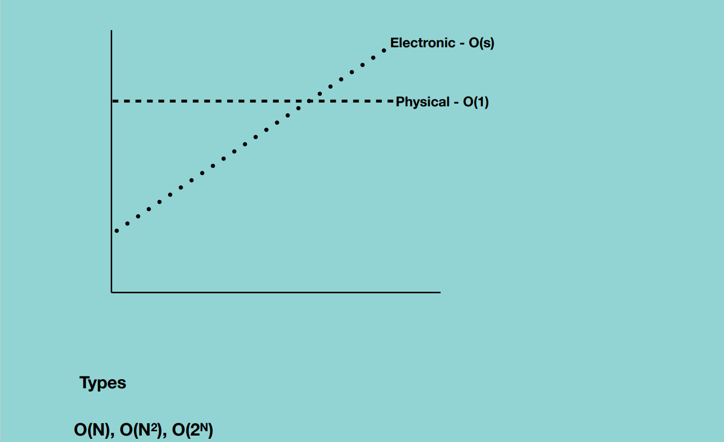

**Big O Notations**

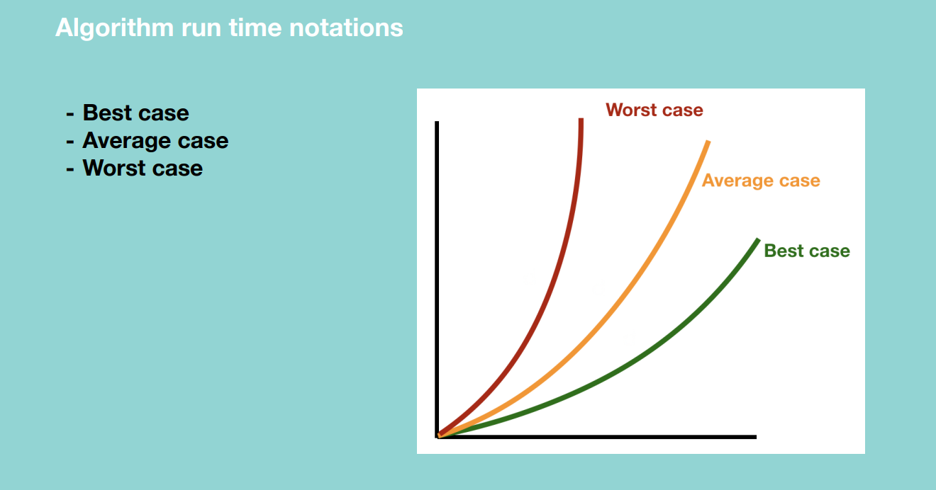

**Quick Sort Algorithm –** Best case, all numbers are equal and we pass through the numbers only once hence O(N).

* + Worst case, pivot is biggest in the array hence O(N^2)
  + Average case – sometimes the pivot number will be very high and sometimes will be very low but will not happen over and over again.

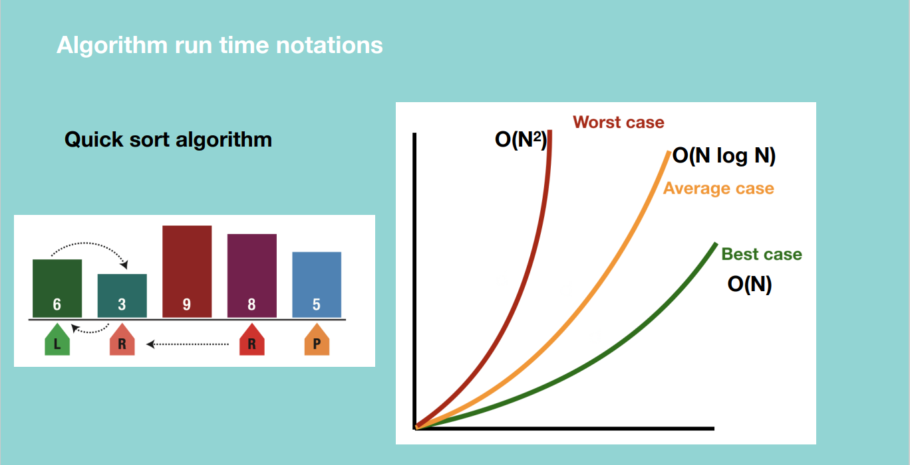

Big O – thinks of the maximum time i.e. a certain operation will never be more than a certain amount of execution time.

Big Omega – thinks of the minimum time i.e. a certain operation will never be less than a certain amount of execution time.

Big Theta – thinks of the average time i.e. if we have an algorithm with max execution time 10 seconds and minimum execution time 1 seconds, the average time will be 5 seconds.

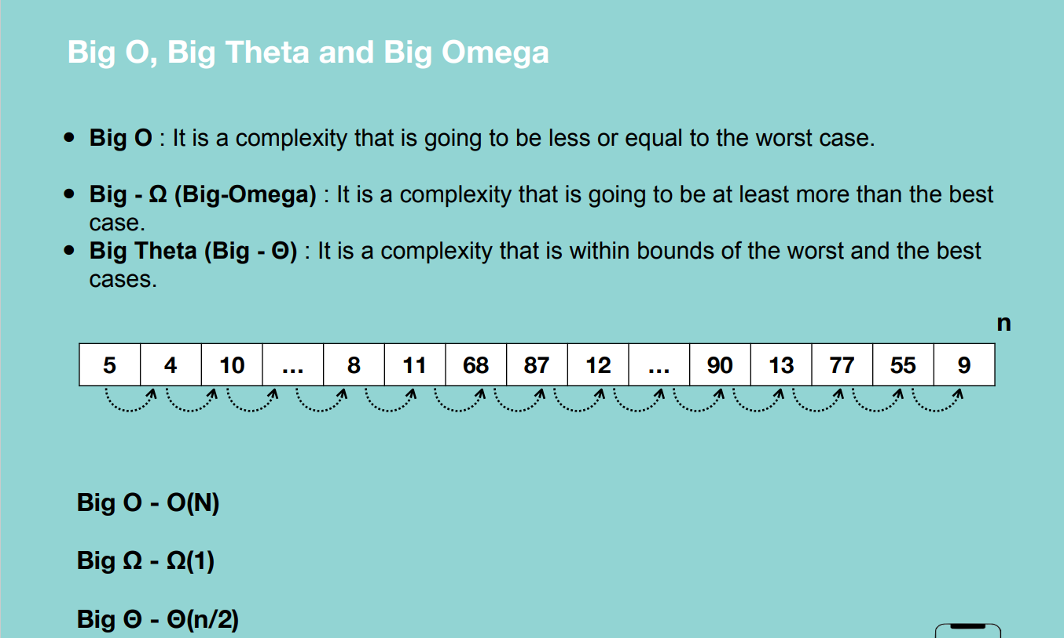

From the figure above, let’s say we take 1ms to move from one element of the array to another.

**Algorithm run time complexities.**

**O(1) –** for any given input, the execution time will not change.

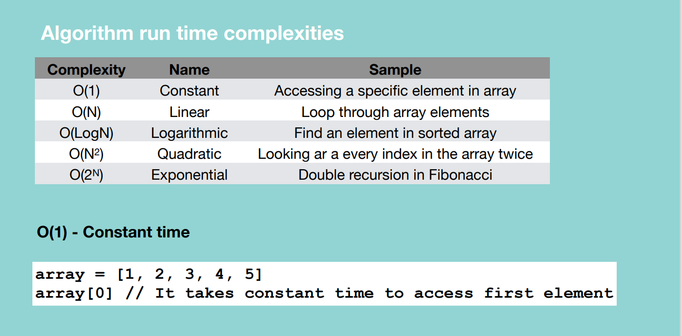

Grabbing a random card in a take takes constant time whatever we grab.

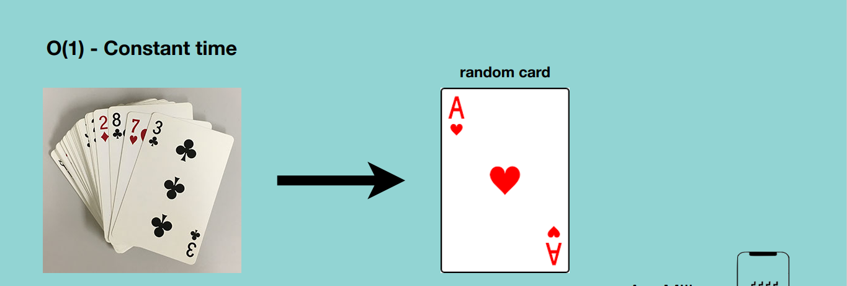

**O(N) – Linear time –** time complexity will grow directly proportional to the size of input data.

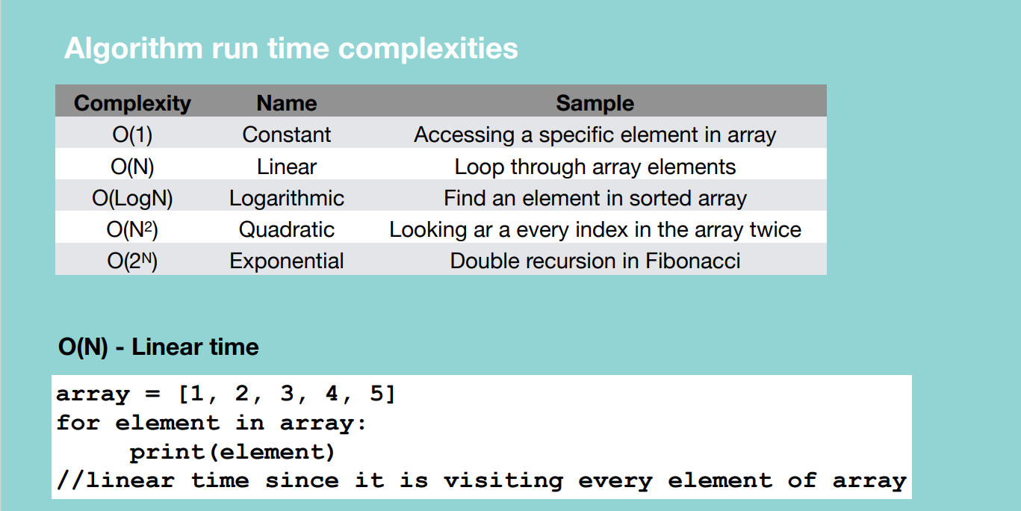

Grabbing a specific card in a take takes constant time whatever we grab.

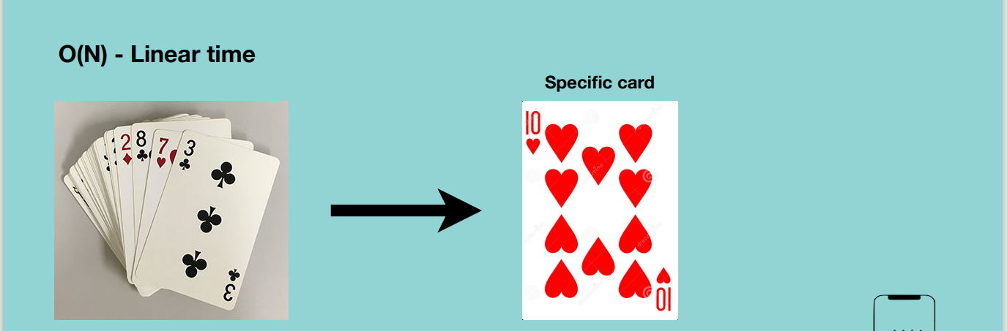

**O(LogN) – Logarithmic –** runs in proportional to the logarithmic of the input size. E.g. if the function doesn’t pass through all the elements in an array

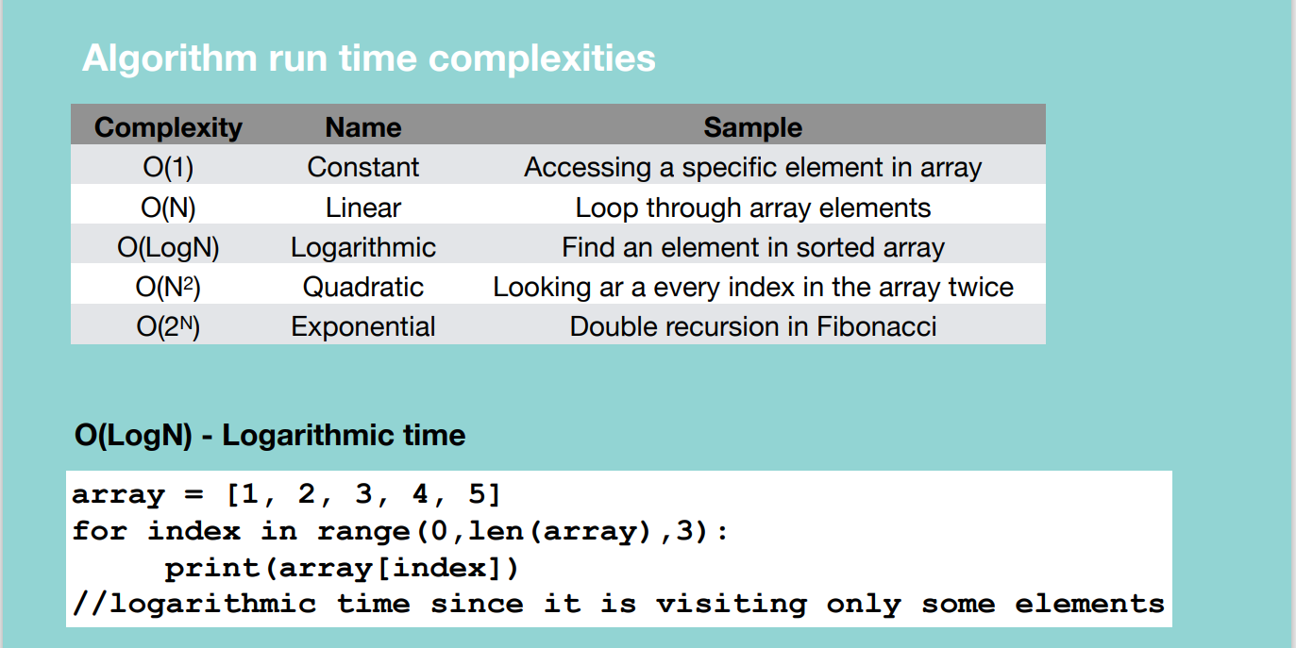

In the example above, we print elements of the array using a step of 3.

Below shows a procedure of trying to find a 10 of hearts in a sorted card deck by continuously dividing the problem space.

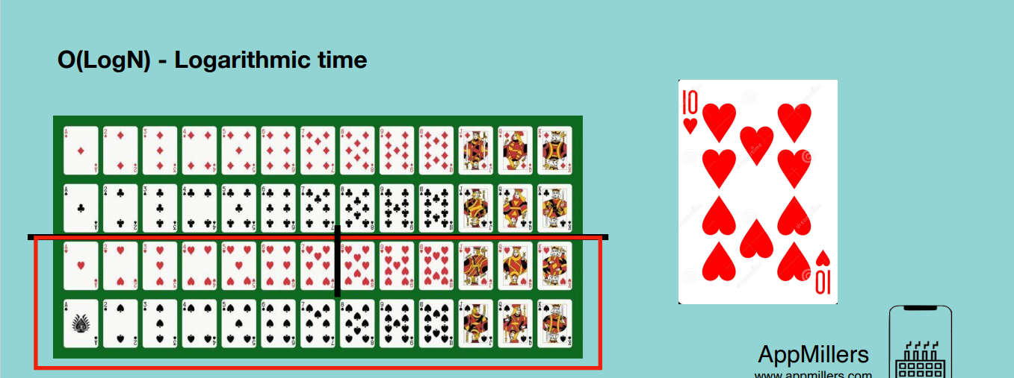

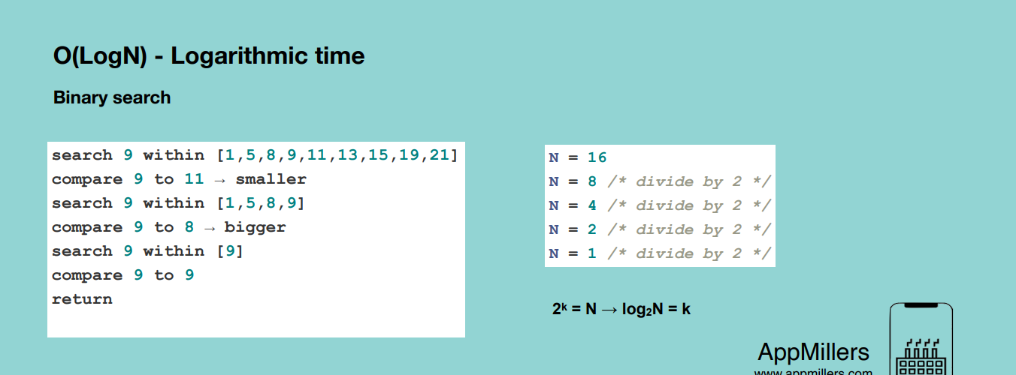

**O(N^2) – Quadratic time** – an algorithm whose performance is directly proportional to the square size of the input data set. It’s like linear algorithm but here the time complexity is increasing quadratically. It occurs whenever we nest our multiple iterations.

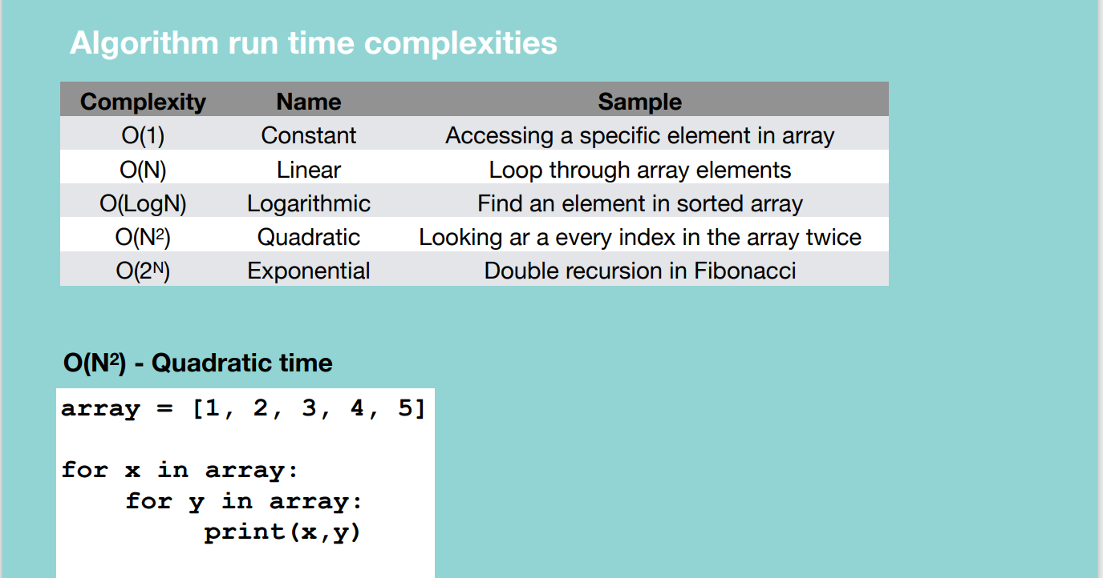

Eg. Revisiting the deck of cards each time we want to pick a card of 3.

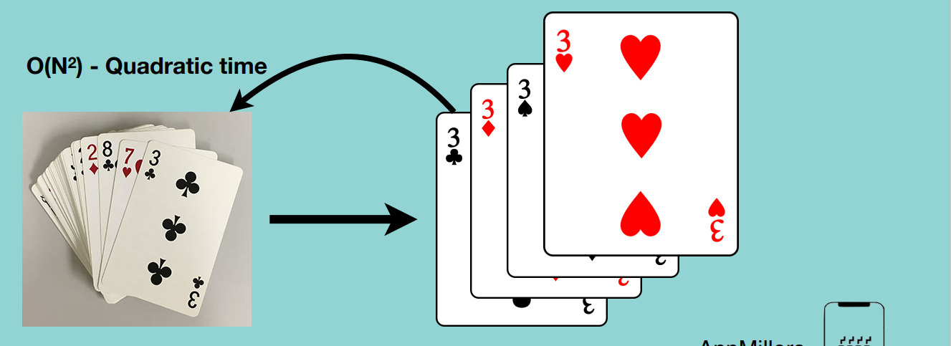

**O(2^N) – Exponential time –** algorithm whose growth doubles with each addition to the input set. Time complexity starts very shallow, rising at an ever increasing rate until the end.

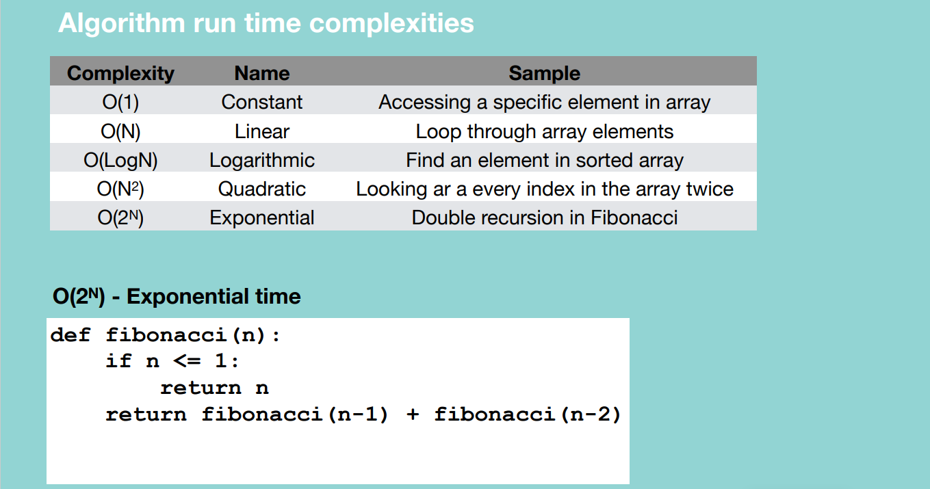

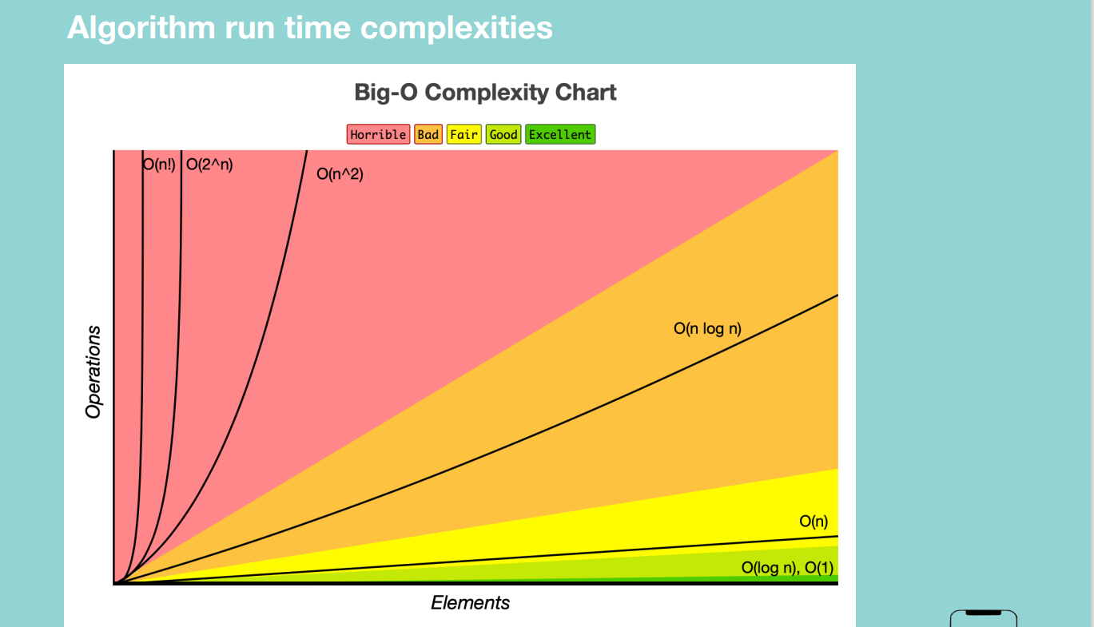

**Space complexity:** measure of the amount of working storage an algorithm needs.

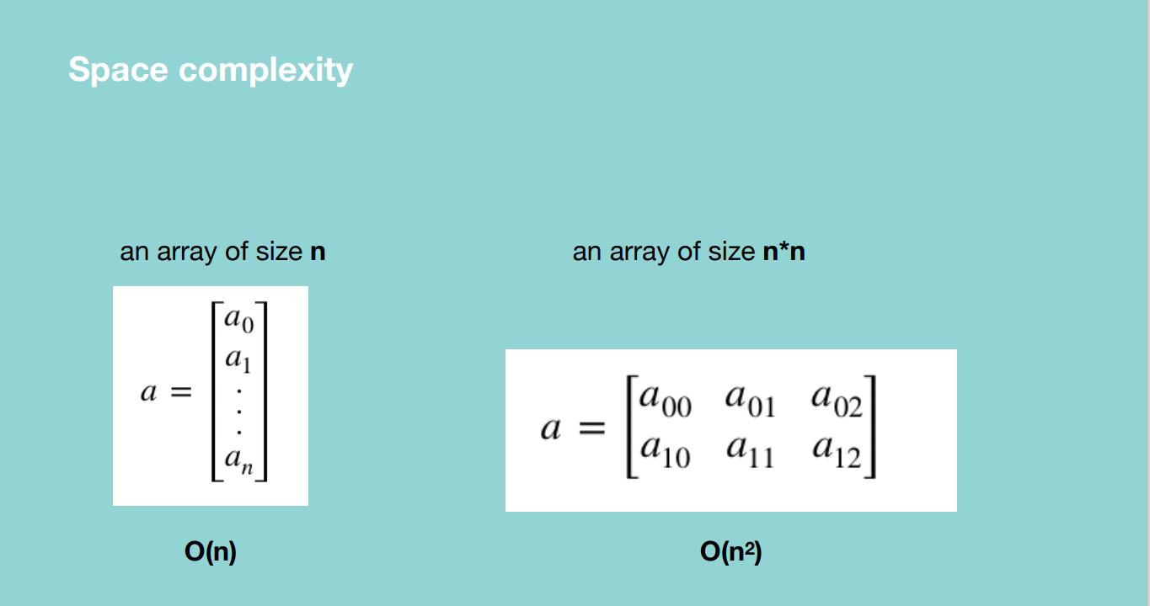

A function which is summing up the number from a given number till zero by calling recursive calls.

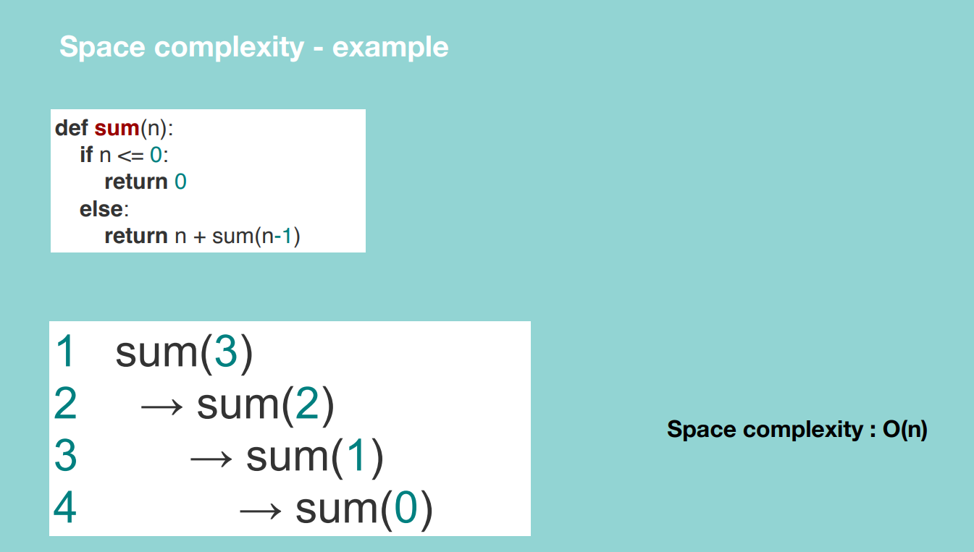

Since the function is not calling itself recursively or adding anything to the call stack.

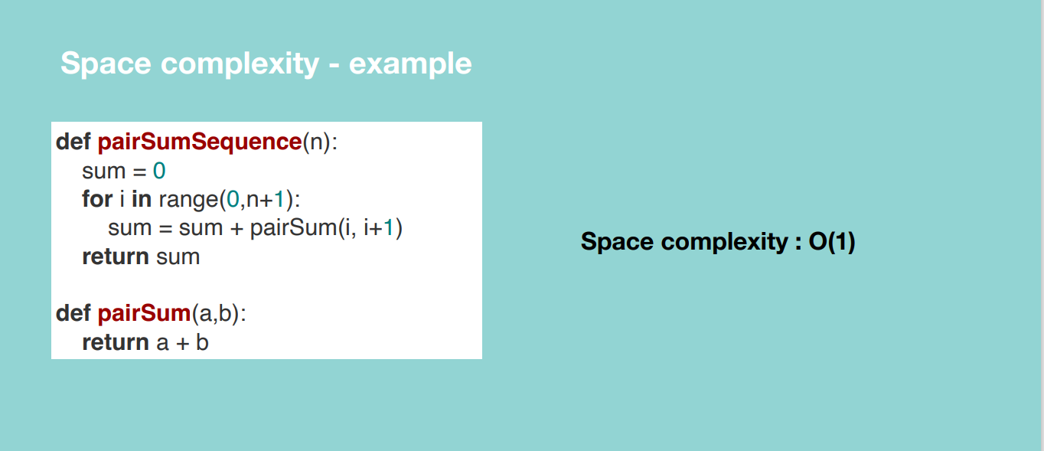

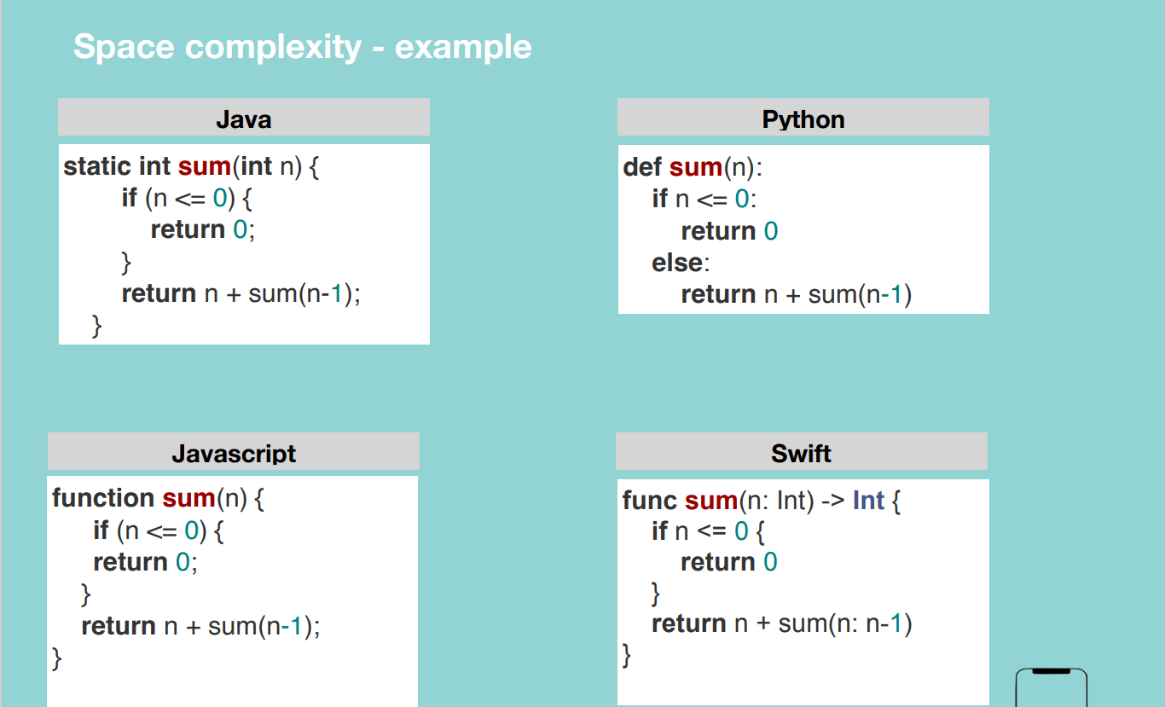

**Drop constants and Non-Dominant Terms**

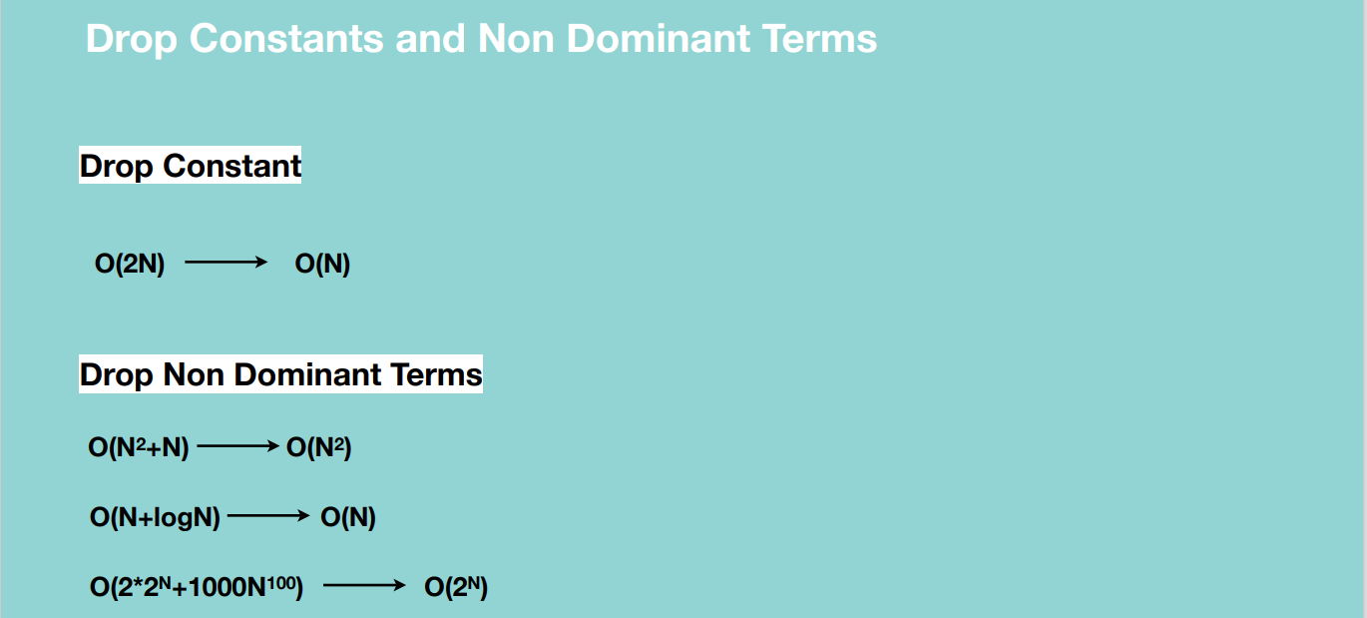

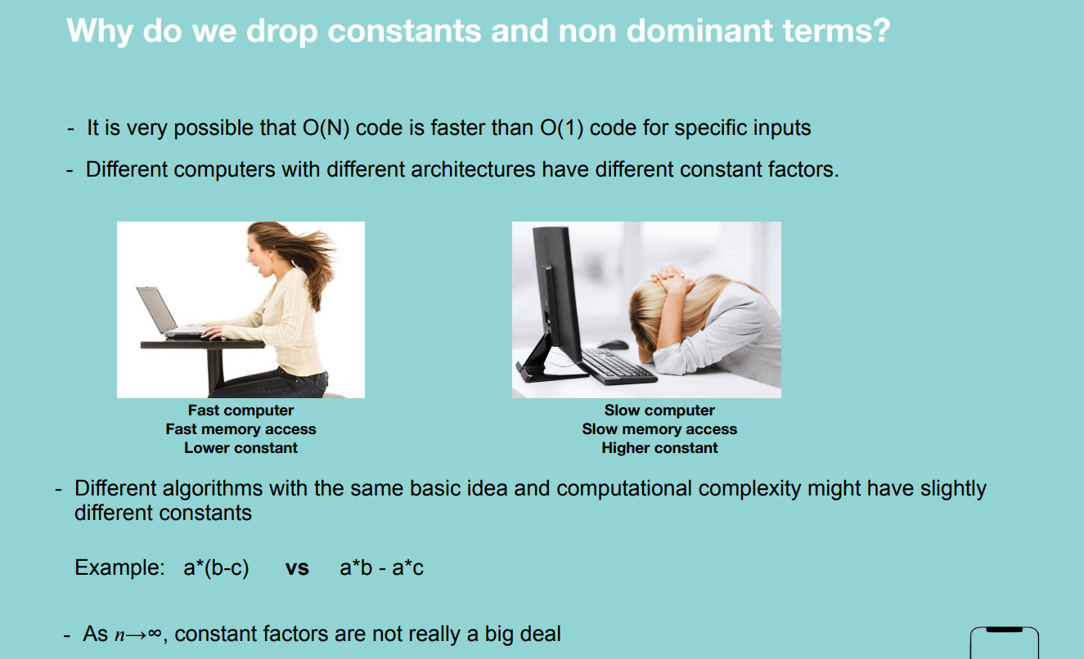

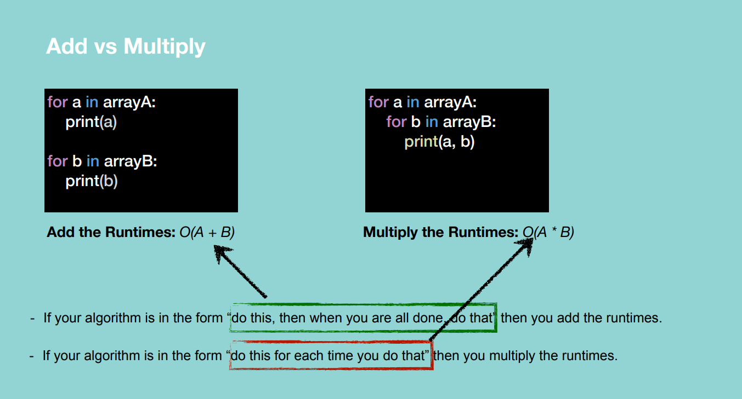

**Note:** the array has a million elements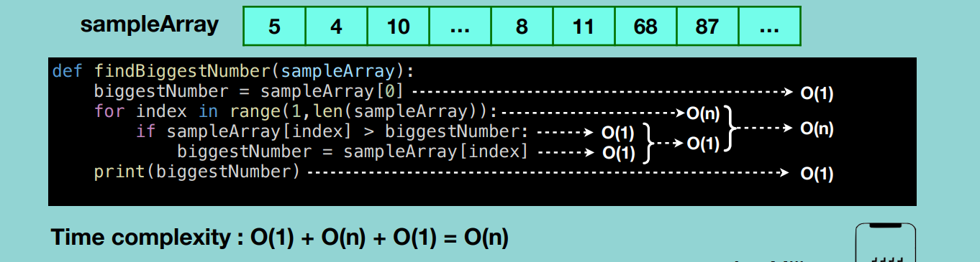

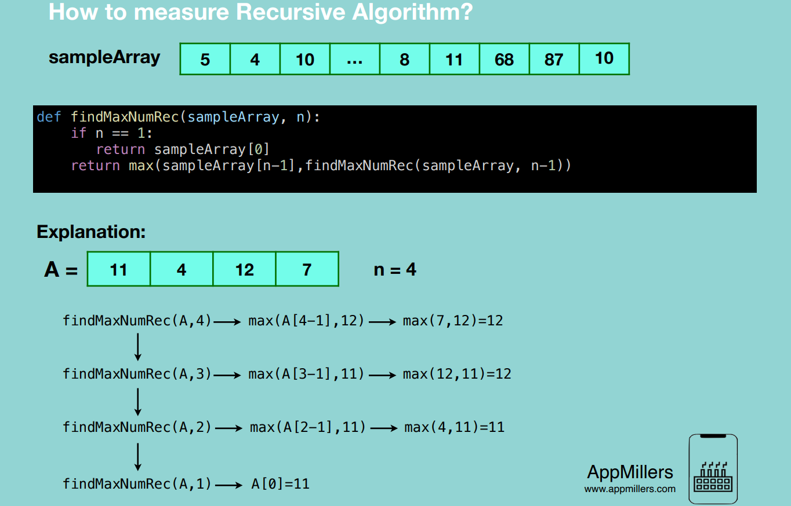

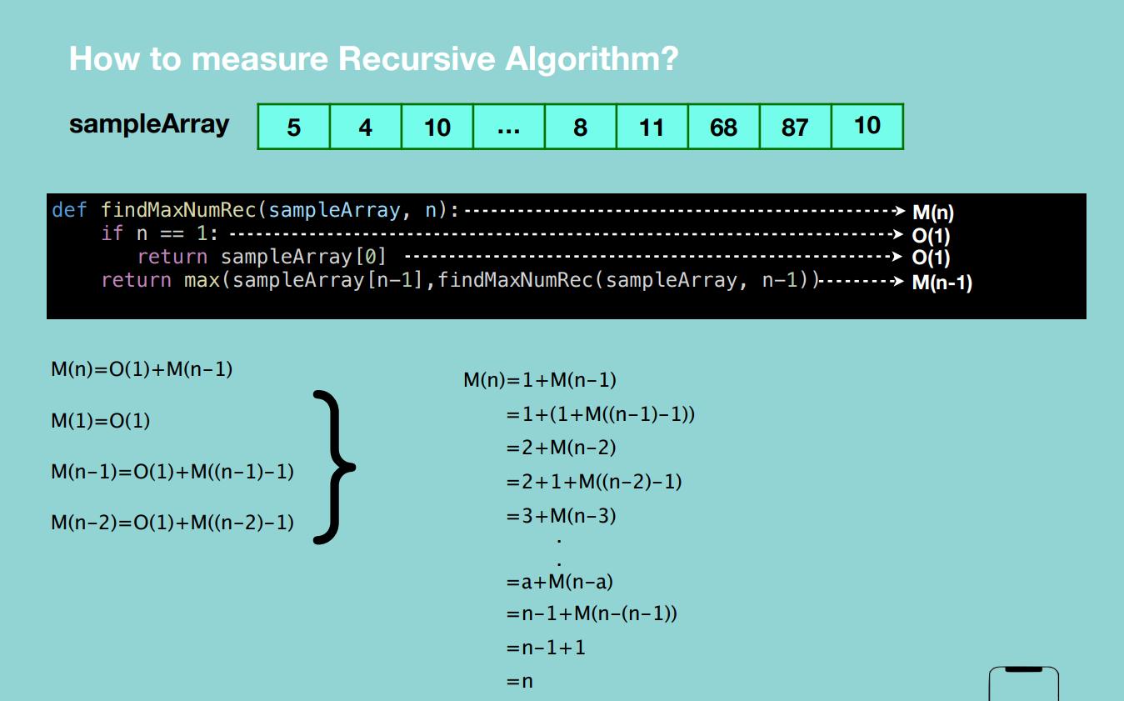

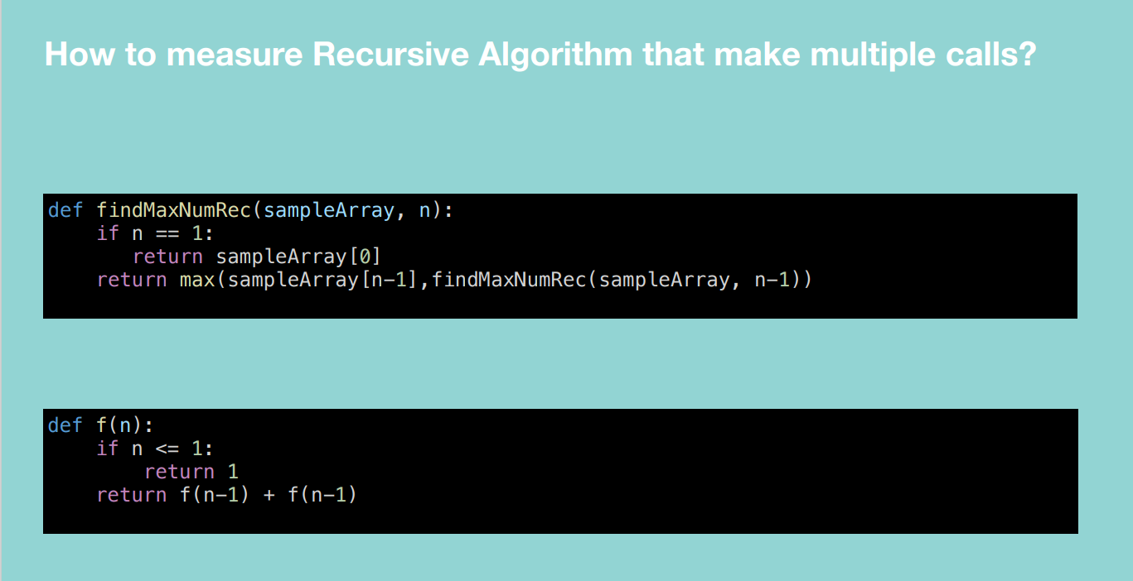

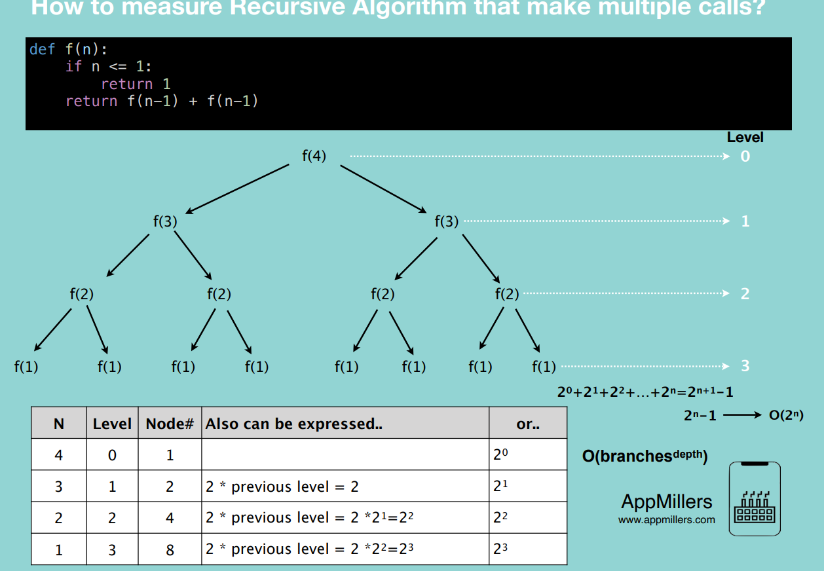

**For a** recursive algorithm with multiple calls, the complexity is **O(branches^depth)** e.g. double recursive calls = O(2^n). triple recursive calls = O(3^n)

**Top 10 Big O interview Questions**

**Found in Cracking the coding interview**

